**Lab 12**

**Interfacing ADC with msp430**

Spring 2025

Submitted by: Mohsin Sajjad

Registration No: 22pwsce2149

Class Section: A

“On my honor, as student of University of Engineering and Technology, I have neither given nor received unauthorized assistance on this academic work.”



Student Signature: ______________

Submitted to:

Engr. Faheem Jan

Month Day, Year (01 06, 2025)

Department of Computer Systems Engineering

University of Engineering and Technology, Peshawar

**Interfacing ADC with msp430**

**TASKS:**

**TASK 01:**

Run the code given in the lecture

**CODD:**

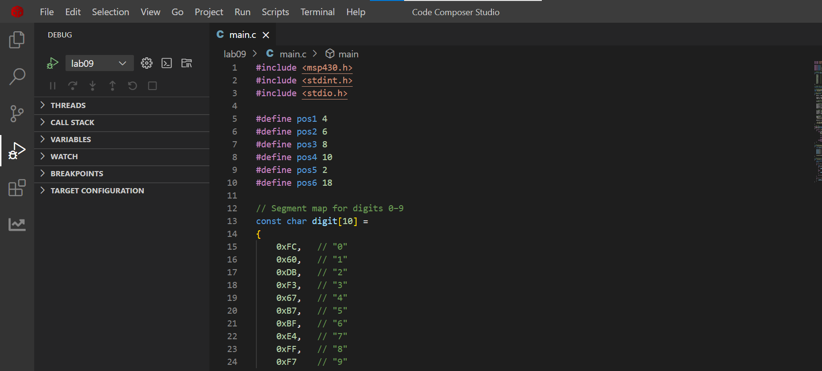

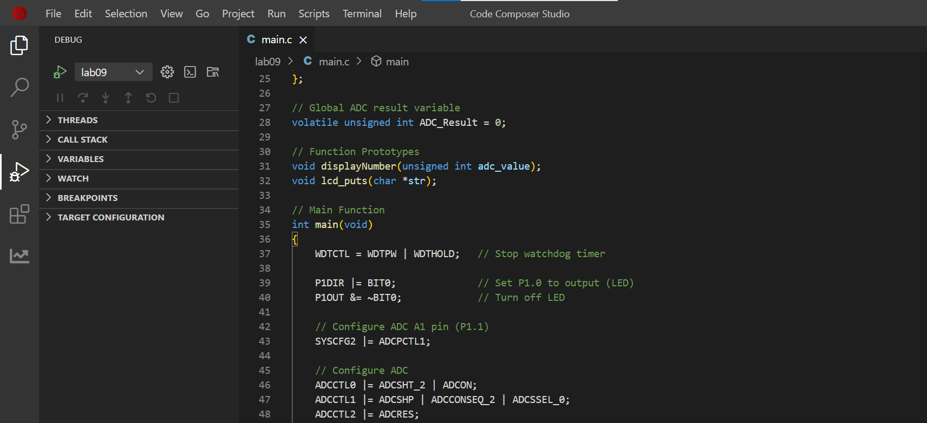

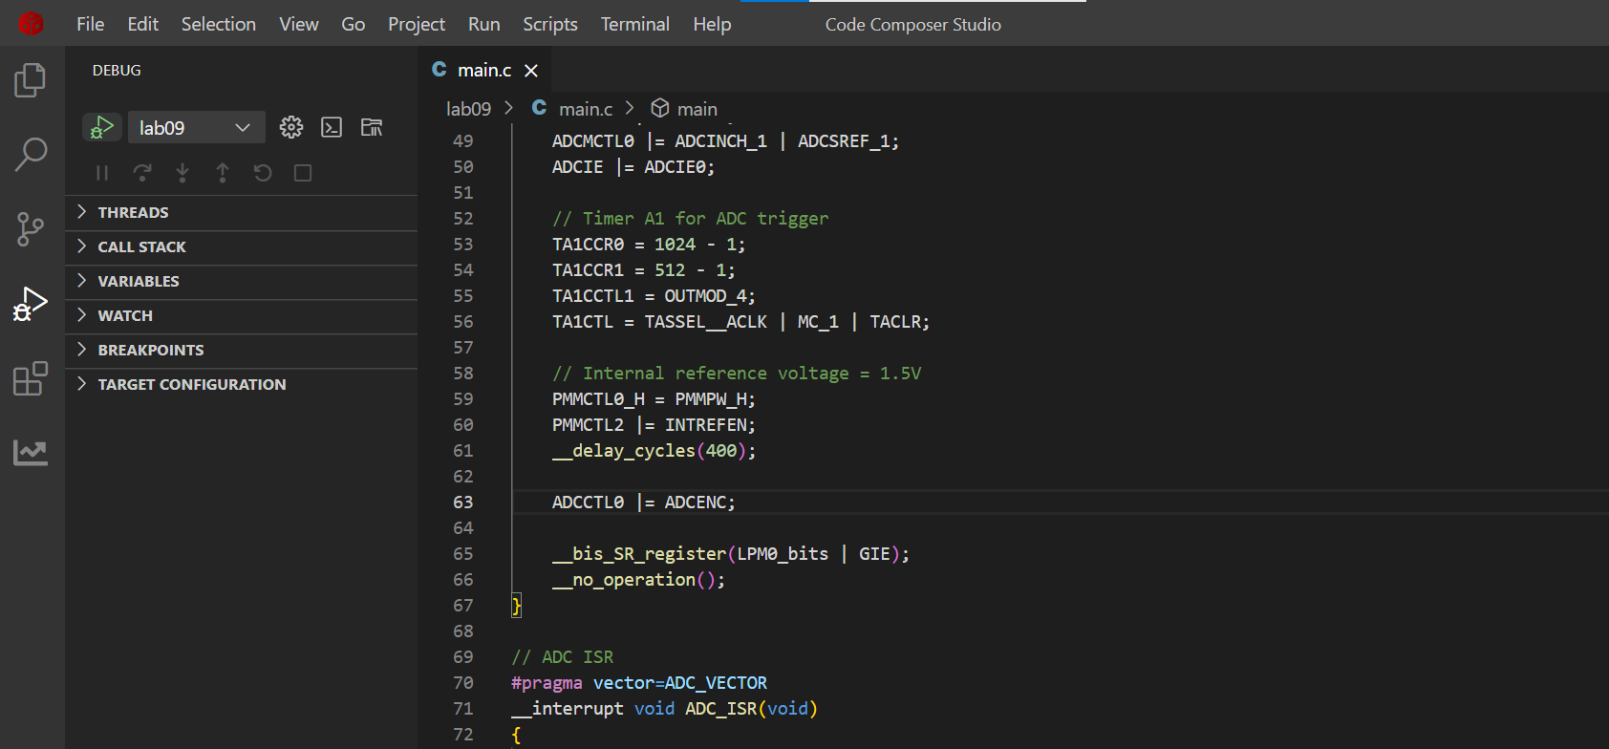

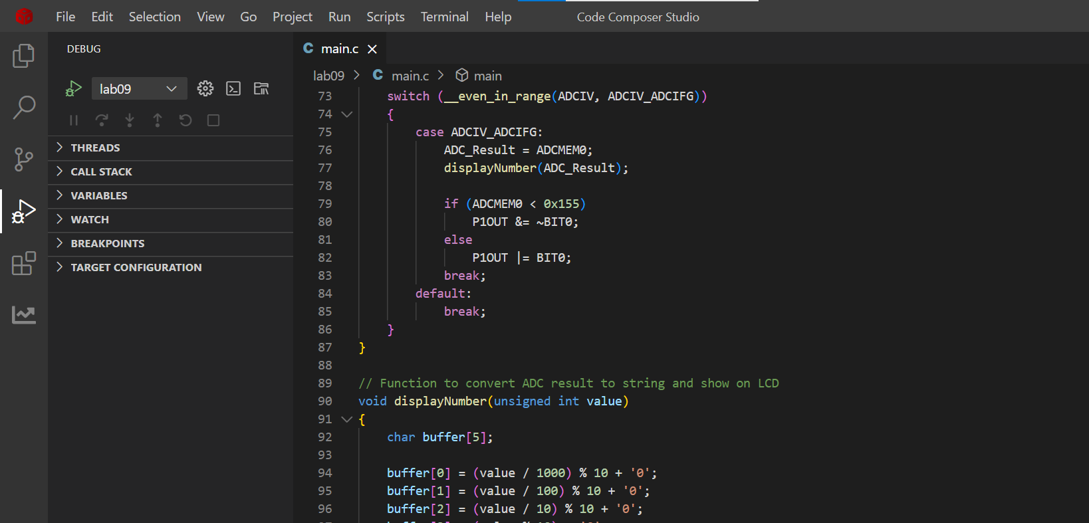

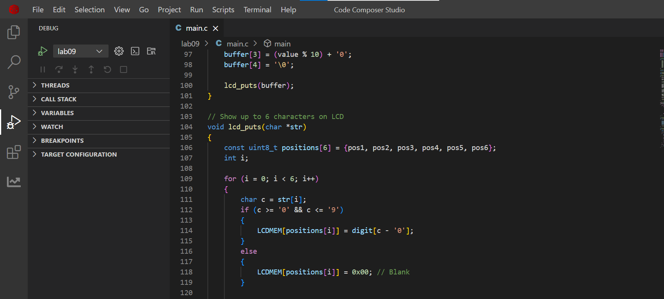

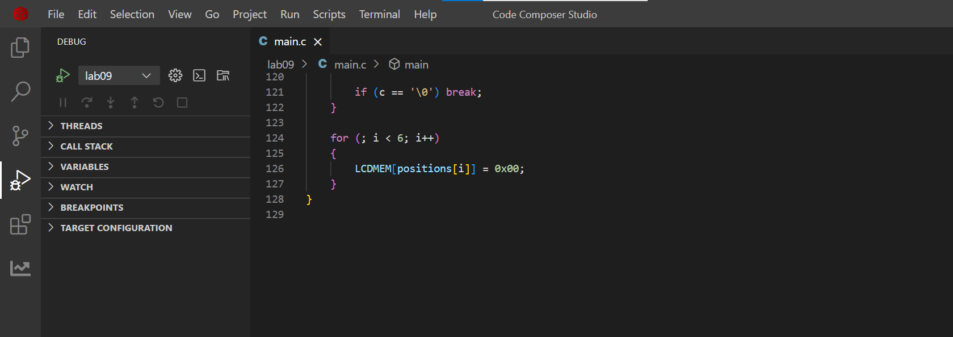

**TASK02:**

From temperature sensor (LM35) read temperature and convert it into Digital value by using ADC0804 and display the value on the LCD. In LCD at first line write your registration Number and on the second line display the value of the temperature sensor attached with ADC0804. ( use proteus can also use MSP430FR4133)

**CODE:**

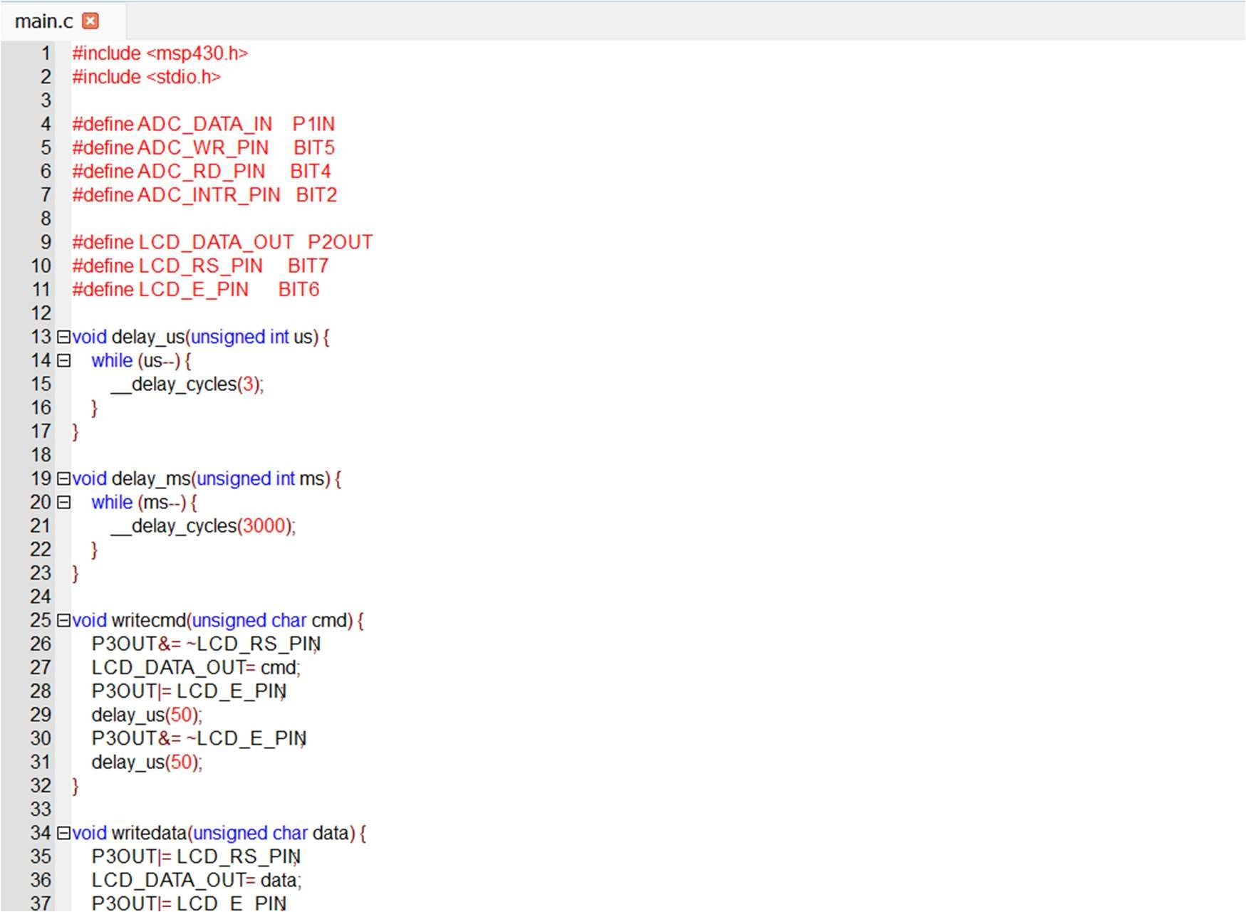

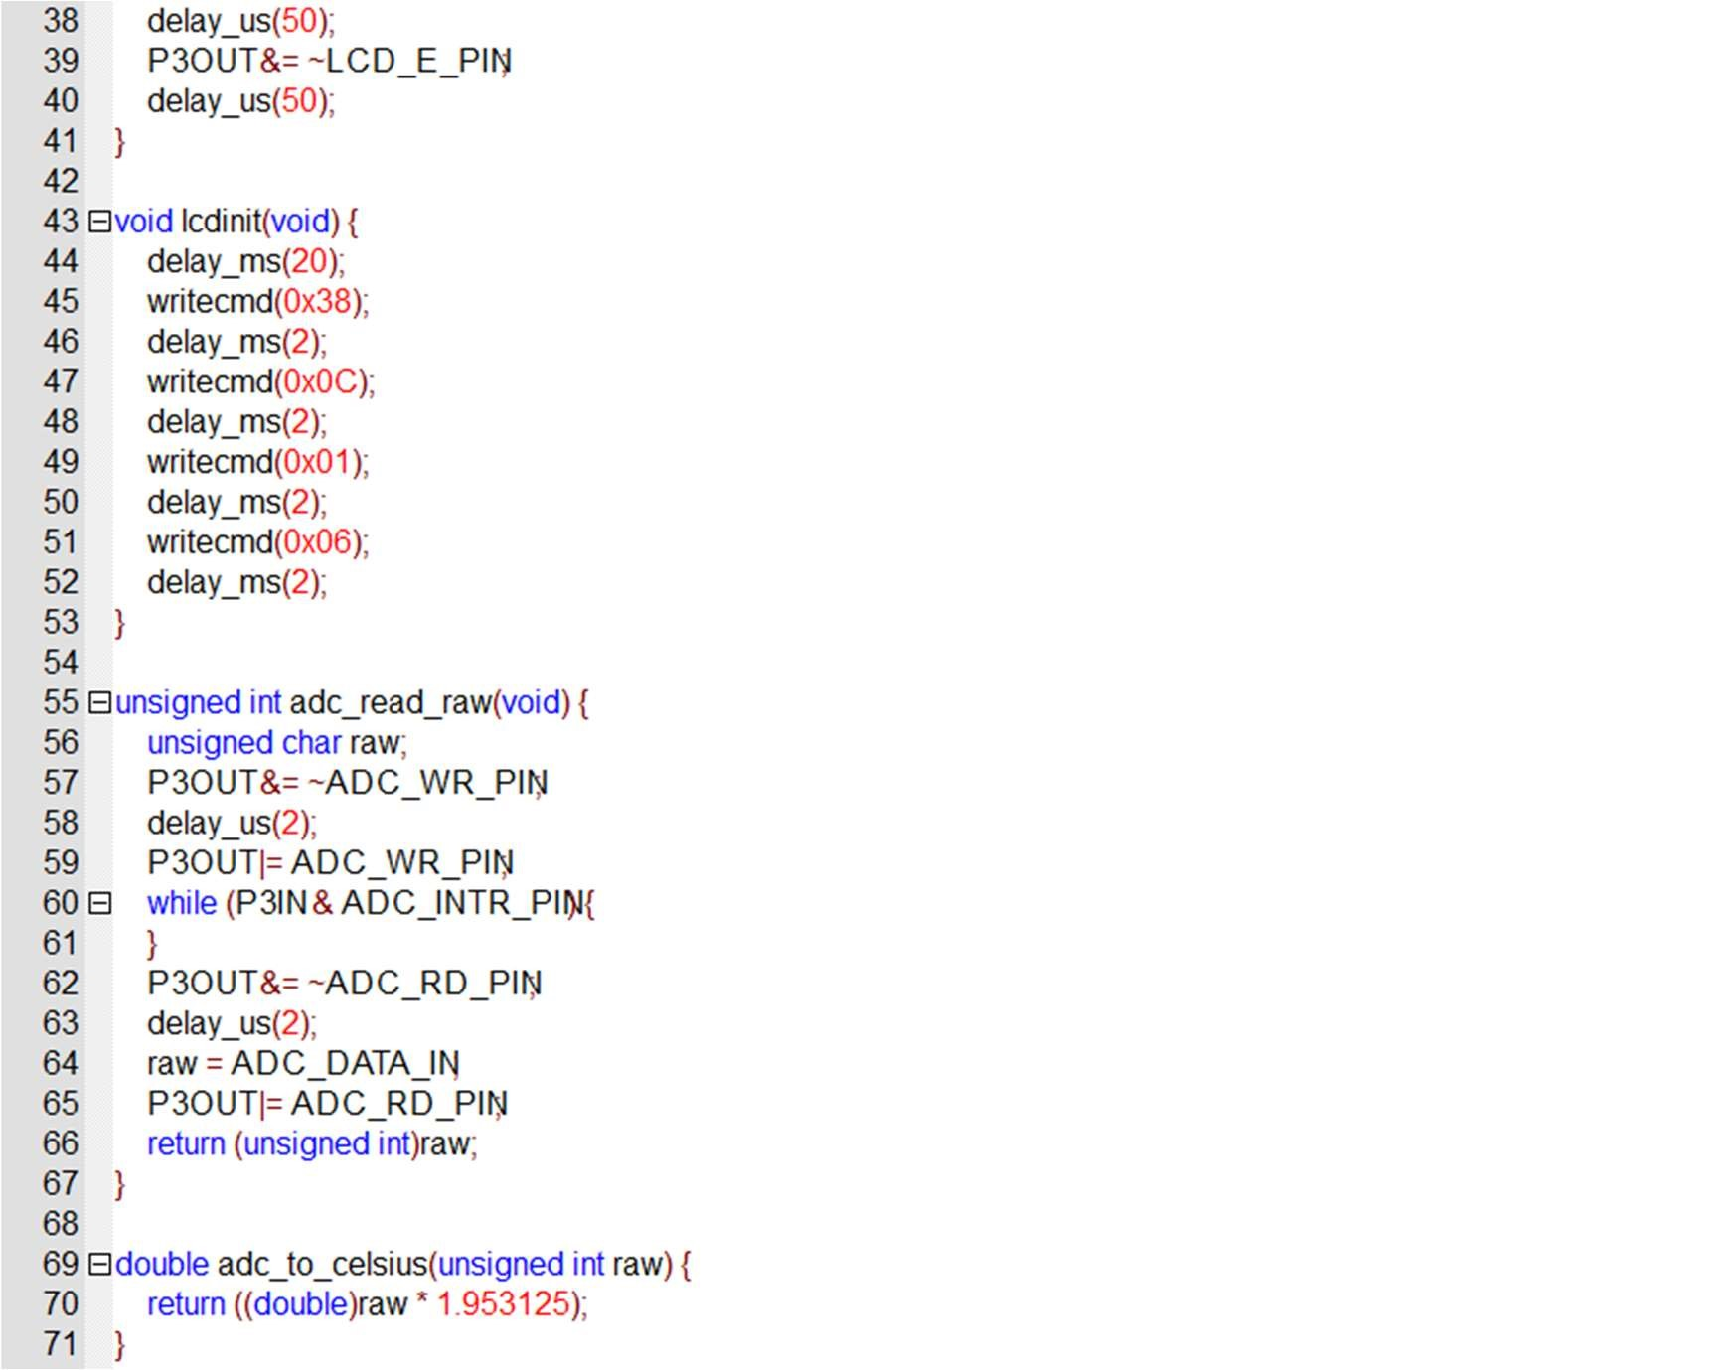

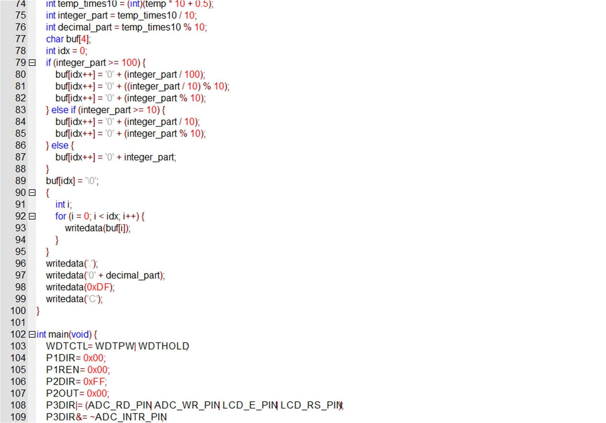

**Output:**

